Questions for the Scrutiny meeting 13 Feb 2023 plus responses & notes on discussion
All our Qs were welcomed and taken seriously. The issues raised were all reflected in the notes of the meeting – will circulate when these are published. The discussion was longer than certainly the CSP chair had expected and was quite testing. She said to us afterwards she is re-standing in May as it has taken her some time to grasp the issues in CSP and understand the complexity of the partners esp police and wants to continue to make progress.
Question 1
As a resident in Herefordshire I am concerned about domestic violence and sexual assaults in our localities. We had a disturbing series of sexual assaults in Hereford last year. My question reflects one of the key concerns of the public meeting held on 28th September in Hereford, sponsored by Herefordshire Labour “Time to tackle Violence Against Women and Girls”, of ensuring action taken delivers results. What are your plans to scrutinise and judge the effectiveness of the new safety campaigns Time for Change aimed at tackling the Community Safety Partnership’s strategy priorities of domestic abuse and sexual assault?
Response to Question 1
The Time for Change campaigns have been funded by the Governments Safer Streets Campaign. Herefordshire and West Mercia Police have been successful with their bids for Safer Streets Funding. Thank you to colleagues who have co-ordinated and delivered the Safer Streets campaigns and to DI Julie Watson who provided this response below on behalf of the Herefordshire Community Safety Partnership.
“The time for change campaign is regularly evaluated. The first phase of the campaign - release of the video and the website, created through Safer Streets 3 funding, was subject to evaluation however we do not have access to the data pertaining to this at this current time.
Safer Streets 4 has taken the Time For Change campaign to run 3 sub campaigns –
- Christmas and New Year
- Student
- Under-represented groups
Each of the three campaigns will undergo independent evaluation for effectiveness and this is being completed by a market research company.
The Christmas and New Year campaign ran through December 2022 until 2 January 2023. This was a high profile campaign run through audio and visual channels – targeted audio messaging, billboard/kiosk visuals and editorial in local press. The audio advert alone was played over 117,000 times with completed listen through rate at just over 95%. This campaign was subject to evaluation with the feedback being positive. 19% said they had seen/heard a campaign in the previous three months which is strong market penetration for an early-stage campaign, and slightly higher than expected. 21.5% say they’ve heard of Safer Streets Herefordshire, and the same amount say they’ve heard of Time for Change. 98% of respondents who were aware of the time for change campaign say they are quite likely or extremely likely to take action if they saw a VAWG crime.
The Student campaign is currently live with the Under-represented groups campaign scheduled for March 2023 therefore we do not have feedback on these yet.”
The feedback above evaluates the effectiveness of the media campaigns, however it does not totally measure changes in behaviour or if people feel safer/ less safe. This is something that the Community Safety Partnership, the Tackling Sexual Violence Priority Group and the Safer Streets Steering Group may wish to consider. Further evaluation may include a repeat of the original community survey that was carried out as part of the evidence gathering to support the original bid for Herefordshire’s Safer Streets funding. Behaviour change takes time and a variety of factors and interventions will contribute to that change.
Supplementary question: What are your plans for extending the Safer Streets work beyond just Hereford City into market towns and villages? There are housing developments in these locations, less lighting and growing issues with safety especially for women and girls.
Response in the meeting: there was huge agreement this was an excellent question – one of the councillors had been going to ask it too. The response was that it is planned to extend Safer Streets in this way as soon as the government funding allows and they expect this to happen.
Question 2
As a resident in Herefordshire I am concerned about domestic violence and sexual assaults in our localities. We had a disturbing series of sexual assaults in Hereford last year. My question reflects one of the key concerns of the public meeting held on 28th September in Hereford, sponsored by Herefordshire Labour “Time to tackle Violence Against Women and Girls”, about the quality of data available to make decisions and guide action by agencies. Are you satisfied that the quality of the data that the Community Safety Partnership receives on domestic violence and sexual assault is good enough to ensure a consistent co-ordinated response from all the agencies and enable evaluation by you and by partners against agreed standards?
Response to Question 2
The Herefordshire Community Safety Partnership paper submitted to the Scrutiny Committee for Monday 13 February 2023 (Appendix A) subsection 17 Data Sharing identifies the need to strengthen community safety multi-agency data sharing arrangements by stating, “….. most of the data provided in the reports is police data only. This is a challenge the CSP has to overcome and undermines the potential value of the strategic analytical reports”, and work is on-going to address this shortfall.
The Office of the Police & Crime Commissioner Community Safety Partnership (CSP) analytical team has provided two excellent police data thematic reviews for the CSP on domestic abuse and on violence against women and girls in Herefordshire*. (*Both marked Official Sensitive.) The sexual violence report informed the draft Herefordshire CSP Sexual Violence Strategy to be presented to the CSP Board in March 2023 which has identified outcomes and measures/ key performance indicators to address sexual violence which will enable interventions to be measured.
Supplementary question: what work is taking place to collect data from the other agencies and not just the police? As the CSP acknowledges that this is a "challenge it has to overcome and it undermines the potential value of the strategic analytical reports”, is the Scrutiny Committee clear about what the obstacles are to achieving better information on which the CSP can base decision making and resource allocation?
Response in the meeting: again agreement this was an excellent question and one they would ‘use as a template’ for their work. It was discussed under the main CSP discussion Hopefully a written reply will be sent to Jacqui.
Question 3
I am a resident of Ledbury, I am concerned about domestic violence and sexual assault in the county. I attended the public meeting on 28 September last year in Hereford, sponsored by Herefordshire Labour “Time to tackle Violence Against Women and Girls”. My question regards concerns about ensuring full participation in the Community Safety Partnership by agencies attending and reporting. Are you satisfied that the partners in the Community Safety Partnership are fully involved in attending and reporting to meetings in 2022/23?
Response to Question 3
Response from Councillor Tyler Chair of the Herefordshire Community Safety Partnership (HCSP).
‘The Herefordshire Community Safety Partnership Board is entrusted to address crime and disorder in Herefordshire. The CSP has agreed that tackling Violence Against Women and Girls is a Strategic Priority and all partners are committed to this priority. As Chair of the HCSP I encourage all partners to engage fully at meetings of the Partnership and its sub groups in order to evidence the impact Partners, both as agencies and individuals, are having on addressing crime and disorder in Herefordshire.’
[Attendance was also reported in the meeting papers as below. No supplementary question asked]
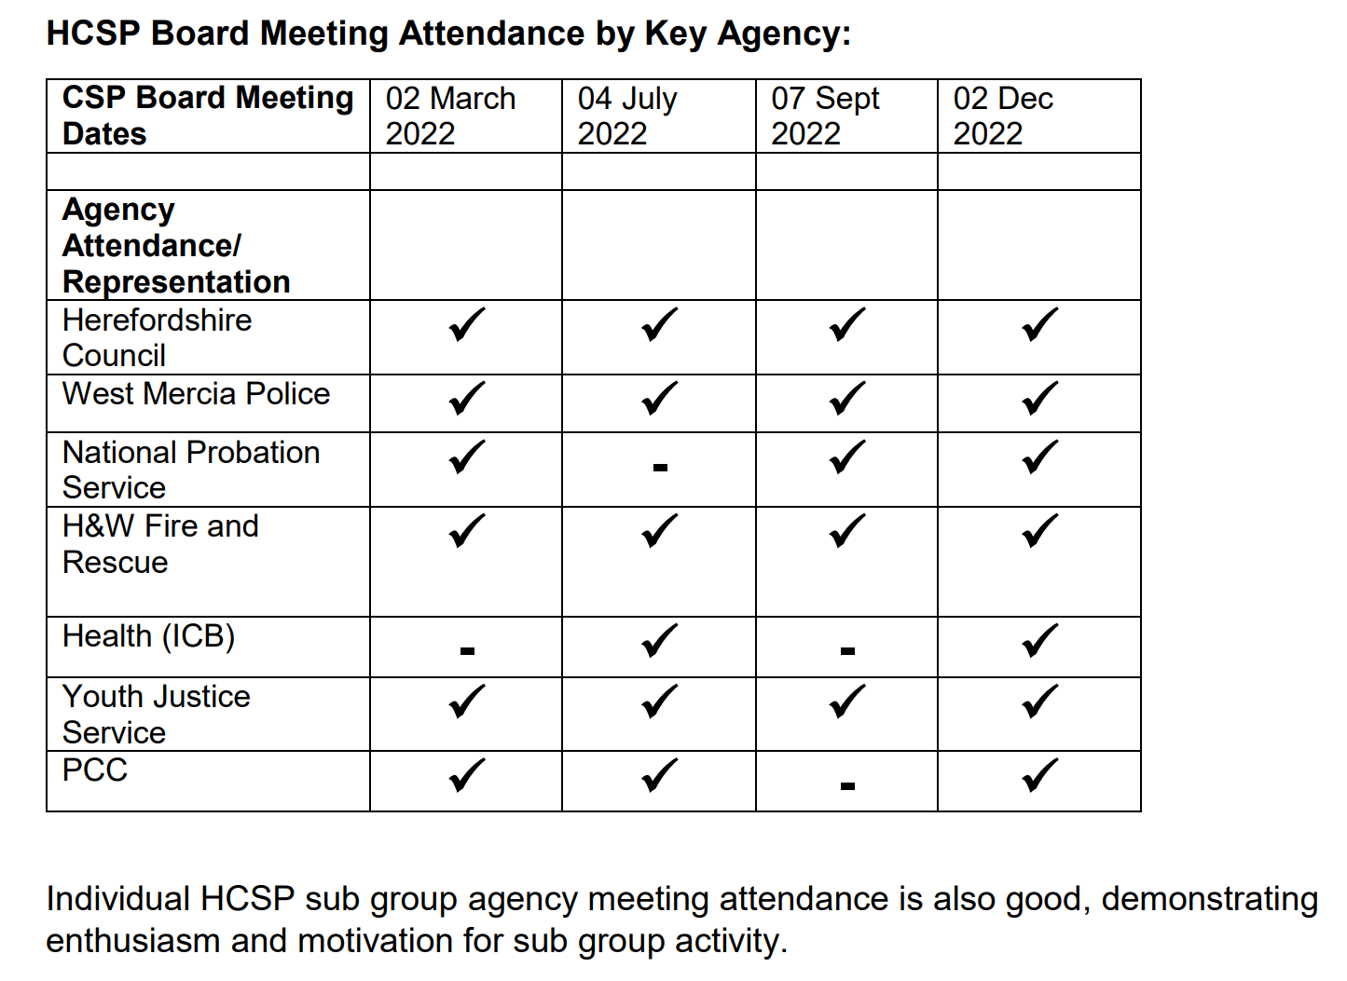
Question 4
As a resident in Herefordshire I am concerned about domestic violence and sexual assaults in our county. We had a disturbing series of sexual assaults in Hereford last year. My question reflects two of the key concerns of the public meeting held on 28th September in Hereford, sponsored by Herefordshire Labour “Time to tackle Violence Against Women and Girls”, of the importance of attitudinal change especially among men and boys, with priority to education in schools and colleges & of ensuring action taken actually delivers results. To assist scrutiny of this area, do you have access to data on how many schools have had the Purple Leaf Programme (and similar Herefordshire wide projects), how far these have changed attitudes and what further plans there are for whole school and countywide initiatives to ensure consistency in all settings?
Response to Question 4
The draft Herefordshire Community Safety Partnership (HCSP) Herefordshire Sexual Violence Strategy 2023-2028 to be agreed by the Herefordshire Community Safety Partnership Board in March 2023 lists the first of three strategic priorities as Priority Area 1: Prioritising Prevention and has the following 4 aims:
- Increase awareness and understanding of sexual violence and its drivers amongst professionals and the community
- Challenge the myths, stereotypes and attitudes, that lead to sexual violence and stop people speaking out
- Strengthen the capacity of educational settings, workplaces, leisure and entertainment venues to prevent sexual violence
- Ensure that families, children and young people have access to educational resources on consent, healthy, respectful relationships and sexual violence
Clearly this will involve interventions such as Purple Leaf and programmes in schools to see how far these have changed attitudes and what further plans there are for whole school and countywide initiatives to ensure consistency in all settings.
I am grateful to colleagues at Purple Leaf and the Safer Streets Steering Group with the following response below:
“We (Safer Streets) have delivered sessions to Years 6, 9 and 12 across Herefordshire providing training for 2,706 Children as part of Safer Streets 3 in Herefordshire. Feedback across all sessions and all learning outcomes has been overwhelmingly positive from both teachers and pupils and that schools have approached us for further delivery…….
……… Our Purple Leaf Education programme (specifically delivered in schools and settings where children are at risk of/ may have experienced exploitation) continues to run in Herefordshire. The programme is currently funding by West Mercia PCC and is due to continue the current contract until 31/3/24. Again, feedback from this programme is consistently positive.”
Information on which schools have received the support is not available at this time.
Addressing the question; “what further plans there are for whole school and countywide initiatives to ensure consistency in all settings?” there is ongoing dialogue with Safer Streets programme leads and commissioners, the West Mercia Sexual violence forum, and the HCSP tackling Sexual Violence Group as to future funding and commissioning. There have been commissioning challenges but I am informed that these are to be resolved. The outline plan is to continue delivery of these core subjects in Herefordshire through a train the teacher model

Supplementary question: How is any change in attitudes being evaluated as against immediate positive feedback from participants? How can this evaluation be developed with a ‘train the teacher’ model since this takes the intervention another step away from the attitudinal change we are seeking?

Response in the meeting: agreement they are awaiting more feedback planned in 12 months time. The work is ongoing and they will report further on it. Again thanked us for a helpful question.

Committee discussion points relevant to our concerns:
- councillors re-raised the issue of measuring outcomes from the schools programme. The point was made that outcomes should be determined in advance and baselines taken and then change measured. Suggestions to check how other areas collect evidence of change. Good discussion.
- The PCC John Campion made several clear statements about supporting the VAWG work and generally being there to help – his access to funding is key. His aim is to drive outcomes through influencing how WM Police spend their £270m. He feels the current funds and action in schools is a ‘drop in the ocean’ and he favours a much bigger ‘sheep-dip’ approach. But he and other conservatives there also stated that ‘not everything needs funding’ citing more use of positive messaging especially on social media – which as we all know takes time, expertise and person power to achieve. Sigh.
- Some good discussion about supporting money for schools to add to their resources for pastoral care for children and young people, including for those in care, to combat abuse and violence of all kinds through early intervention. Support for bringing the voice of YP into this work too.
- The CSP also commissions investigations into ‘domestic homicides’ – of the 9 reviews in the last year (I think) it was stated 8 were of older people and so elder abuse is an area of concern. No info given on gender of the people who died nor their attacker, though was implied it is children of elderly parents.

SM 15 Feb 23

